DESIGN OF MESFET TRANSISTOR Mask USING KLAYOUT
By Issa SIDIBE

INTRODUCTION :
A MESFET (metal–semiconductor field-effect transistor) is a device made of three pins Source Gate Drain
Production MESFETs are operated up to approximately 45 GHz, and are commonly used for microwave frequency communications and radar. The first MESFETs were developed in 1966, and a year later their extremely high frequency RF microwave performance was demonstrated

1st STEP : MESFET BEHAVIOR
1-Difference between ohmic and schottky contact
Whenever a metal and a semiconductor are in intimate contact, there exists a potential barrier between the two that prevents most charge carriers (electrons or holes) from passing from one to the other. Schottky Barrier (rectifying contact), where the junction conducts for one bias polarity, but not the other. Almost all metal-semiconductor junctions will exhibit some of this rectifying behavior.
On the other hand for getting signals into and out of a semiconductor device, we generally want a contact that is Ohmic. Ohmic contacts conduct the same for both polarities. (They obey Ohm's Law).

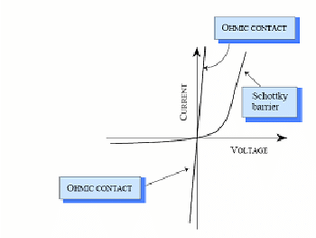
Notice : the bias is apply on the gate (G)
2- MESFET type of contatcts :
For the such a devices we have the both type of contact
For the gate it an schottky contact
For the Drain and sources we have ohmic contact

3- Behavior explanation :
-The gate voltage controls the flow of current through the channel. In an N-channel MESFET (NPN), a negative voltage applied to the gate relative to the source (VGS) creates an electric field that depletes the channel of free charge carriers (electrons) near the surface. This depletion region impedes the flow of electrons from the source to the drain.
-when there is no bias on the Gate (no voltage) , the channel is open but we have no move of electron as long as the voltage is nought
- By applying reverse bias chanel get pinched off no electron is able to go from source to the drain
-whent the gate-to-source voltage becomes more negative than a certain treshold value, the channel starts to conduct. Increasing the negative gate voltage further enhances the electron flow, allowing more current to pass through the channel from the source to the drain.

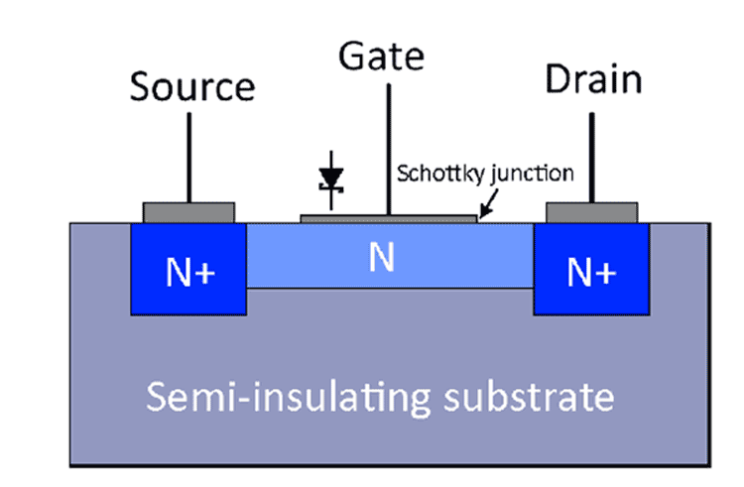

2nd part :
Description of the technological steps :
-5 The three main steps
1st-ISOLATION (Mesa)

2nd – Ohmic Contacts

3rd – Gate contact

fabrication of isolation mesa or resist
- A masking layer, often made of Viscous liquid that becomes solid after evaporation of a
solvent , is deposited uniformly across the substrate. This layer acts as a protective mask for subsequent etching steps
- A pattern is defined on the masking layer using photolithography techniques. Photomasks are used to expose specific areas, creating a pattern for the isolation mesas.
Etching is then applied to remove the exposed regions of the masking layer, revealing the underlying substrate.
After etching, thorough cleaning of the substrate is performed to remove any residues

fabrication of ohmic contact : (Low resistance)
Thoroughly clean the semiconductor surface to remove any contaminants or oxides that might interfere with the contact formation. This cleaning is crucial to ensure good adhesion and low contact resistance.
By using another layer than the previous one, we apply photolithography to define patterns for the metal contacts. A photoresist is applied and exposed to light through a mask, defining the areas where the metal should remain.
- Select a suitable metal or alloy that forms a good ohmic contact with the semiconductor material. Metals nickel (Ni), or gold (Au), Germanium are commonly used.
- Deposit the chosen metal onto the semiconductor surface
- Afterward we do the annealing to restaure the crystal properties for well working way

Fabrication of schottky contact
Clean again the wafer to remove any contaminants
Now we define a third layer for the schottky by applying photoresist and expose it to light through a mask, defining the areas where the metal should remain.
Choose a metal with suitable properties for forming Schottky contacts, such as , titanium (Ti).
- Deposit the metal layer onto the semiconductor surface using techniques like sputtering, evaporation, or chemical deposition. The metal layer is typically thin.
- After the annealing to restaure the crystal properties use photolithography to define patterns for the metal contacts.

3rd Part : Mask designing
Creating a mask for a MESFET (Metal-Semiconductor Field-Effect Transistor) involves designing the layout using KLayout.

We Understand the specifications and parameters of the MESFET transistor you want to design. This includes gate width, length, source, drain, and other geometrical features.

For our case
Gate : 9um
Source : 10 um
Drain : 10 um
Mesa : 20 um
see the gds file joined for details

Conclusion :
In conclusion, it's evident that the fabrication of this device (MESFET) is intricate. It's crucial to prioritize both size and alignment accuracy throughout the process. Additionally, between each step, meticulous substrate cleaning is essential to prevent contamination.

